From Scribbling to Writing Sentences
How to Get Ready for Preschool and Kindergarten
the simple, natural, and right way
By Tracy Cheney

Small children progress through definite stages of human development. One important place we see this is in their drawings, as it is a mental activity first. Children must draw their way to each stage. From “reading” the artwork, you gain insight into your child’s thinking. This is vital brain development work done by the young child that must take place long before attending school.

The way children draw people is a universal phenomena, evolving in predictable ways. After scribbling for several months, a circular shape evolves. When your child realizes it can symbolize a person, that’s a EUREKA moment in their thinking! It’s a brilliant leap for a young human! Communicating with symbols is a unique human activity. But they won’t experience this if they don’t do the work of making lots of art marks first.

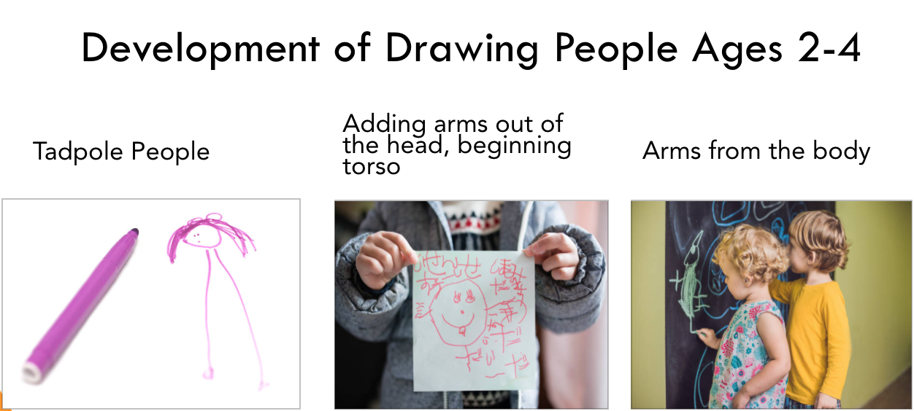

People are usually the first, or at least the favorite subject. A big face is what they have been looking at since they were born. They are drawing you! Eventually they’ll figure out how arms and legs are attached, as they only see parts of them when being carried and held. From their short vantage point, it sure looks like you have super long legs! 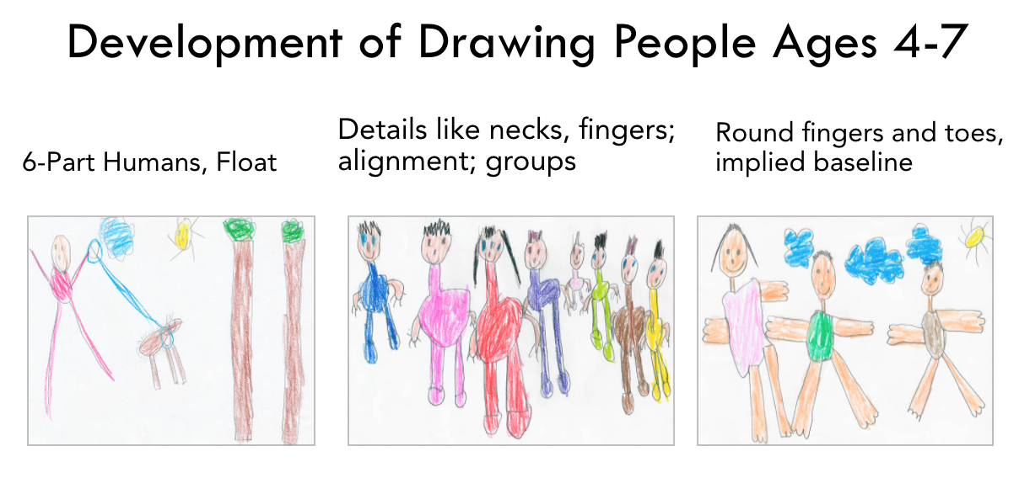At the same time small children are depicting what’s around them, they’re learning to control the drawing materials. They’re developing muscle, eye and hand coordination. By Kindergarten, children are more naturally ready to read and write when they have figured out how to draw people with six parts, and start making them line up on a baseline. That represents a lot of drawing time, observation, and perception of space – all without being able to articulate it verbally. They have drawn their way to the third stage of turning random art marks into recognizable objects, using the visual language first. Writing then evolves gently and fluidly from drawing.
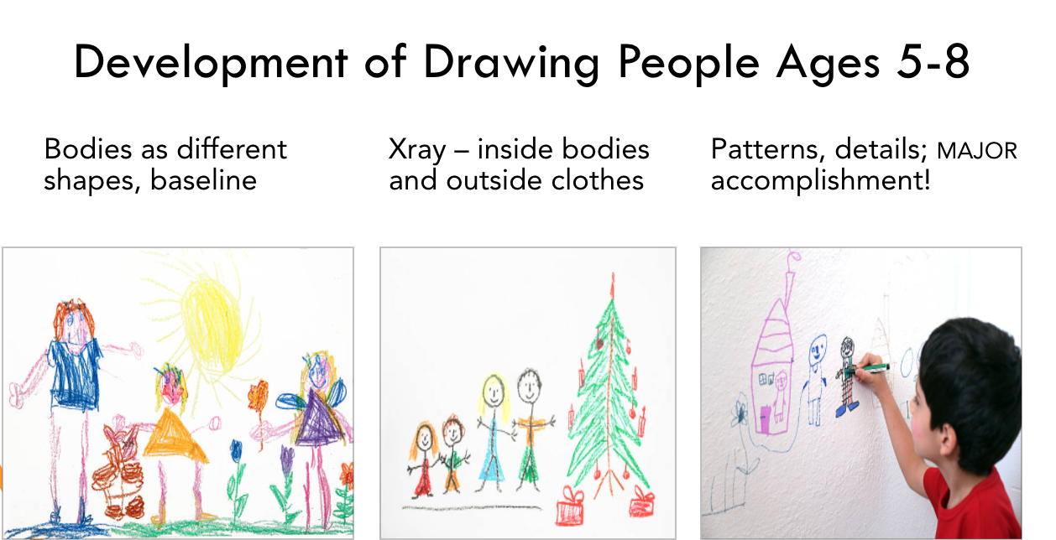
Remember, you don’t have to teach your little ones how to do this! It’s an inside job. They’ll figure it out with enough time devoted to miles of scribbles. From there, they will go on to making truly meaningful marks.
*Drawings from Unsplash, Pixabay, iStock

